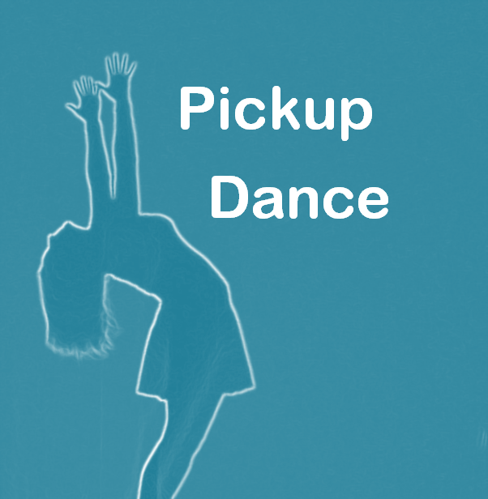
Health & Safety Policy
Statement of Intent:
At Pickup Dance we want everyone to feel safe and secure and we aim to provide a healthy environment for staff and pupils alike.
Pickup Dance recognises the importance of ensuring and maintaining the health, safety and welfare of its employees and pupils therefore it is committed to do all that is reasonably practicable to prevent personal injury and damage to property and to protect everyone from foreseeable hazards. This policy applies to all staff, volunteers, pupils, parents and visitors.

How we achieve this:
-We have current and up to date Public Liability Insurance for all staff members -Members of staff will carry out visual risk assessments before classes start
-Risk assessment forms will be regularly completed and signed throughout the year and will also be done before any additional projects or programmes are started. It is the responsibility of the dance tutor to perform a visual risk assessment before any dace class or any new class in an outside venue
-All adults or guardians will inform staff of any existing medical conditions that may effect their ability to take part or may cause issues to arise within the class

Implementation of Policy:
-Implementation will be achieved by compliance with legal requirements, provision of safe and adequate work systems, strong safety supervision and training to ensure competence on our workplace
-All service users and providers have a responsibility to accept their personal involvement in the practical application of this policy
-All members of staff have a responsibility for promoting and ensuring the practical application of this policy
-The school principle has a responsibility to review and update this policy and to ensure implementation
-Pickup Dance staff have a responsibility for monitoring Health and Safety on a day to day basis
-The doors to the main building are secure and lockable
-The reception area of our studio premises is manned at all opening times
-The doors to the studio has window panes so classes can always be viewed and children and staff can be seen at all times
-Registers for each class are taken
-Health and Safety signage is displayed throughout the studio building
-Cleaning products are stored in a separate room and are out of reach of children and young people
-A no smoking policy is in operation for all areas of the building
-The principle will perform an annual risk assessment evaluation for the building and take action on their findings. Should any health and safety risks in the building be identified on occasions other than dance classes they should be reported to a member of staff who will make the area safe and secure or inaccessible to the public until such time as the problem is rectified

Fire Procedure
-Fire exits are located at the main entrance the back door which leads to the outside stairs. These are always accessible and free from blockages
-If the fire alarm sounds everyone should make their way to the car park and assemble outside the building
-A designated staff member will bring out any registration documents to ensure no one is left in the building and will contact emergency services
-Should a fire drill be scheduled all people in the building will be made aware of the times.

Accidents and Emergencies:
-A first aid trained person is always present during classes
-A first aid box is accessible for staff and is located in the supply cupboard, middle shelf
-All accidents are recorded. Should treatment other than first aid be needed, staff will contact emergency services and if necessary, accompany the victim to the hospital until a family member can be contacted
-All customers will have agreed to allow this on their consent forms
-Should any medication need to be administered for young people. Staff will ensure that a consent form has been signed by guardian, medication is kept in a safe place, dosage is witnessed by another responsible adult and a medication form is completed, signed and witnessed by another responsible adult

Previous issues with premises that they have quickly fixed
-Loose light fixture was repaired
-A leaking radiator pipe was repaired

