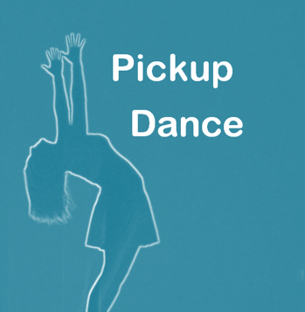
Child Protection Policy

Pickup Dance Southampton identifies the need and function for a policy to be in place to ensure the correct procedures are always carried out for the safety of teachers and students of the school. The dance school has a duty of care to safeguard all children involved from harm. All children have the right to protection and the needs of disabled children and vulnerable children must be taken into account. The dance school will ensure the safety and protection of all children through adherence to the Child Protection guidelines. A child is defined under 18 in The Children Act 1989. The UK’s four nations – England, Northern Ireland, Scotland and Wales – have their own child protection system and laws to help protect children from abuse and neglect. Each nation has a framework of legislation, guidance and practice to identify children who are at risk of harm, and to take action to protect those children and prevent further abuse occurring. We are all responsible for reporting concerns about a child’s welfare. If a child is in immediate danger, then call the police on 999, NSPCC also have a hotline you can call 0808 800 5000. 2020-2021 recorded 50,010 children in England identified as needing child protection plans!

Bryony Pickup is the child protection officer for Pickup Dance Southampton and can be contacted on the school’s email pickupdance2014@gmail.com or through her private email bryony-pickup@hotmail.co.uk. If you would like to elevate your concern further, you can call Southampton County Council on 023 8083 3336

Reports can also be made to MASH (muliti agency safeguarding hub) to provide triage in respect to vulnerable children and adults. Reports can be made where they will share information from every agency and make assessments and decisions on how to proceed and the most appropriate intervention. Daytime phone number 0300 555 1384 and out of hours phone number 0300 555 1373. Online reports can be made by googling MASH children and families.

Pickup Dance Southampton’s Policy
-Always ensure safety of children while at the dance school
-Check the premises are cleaned regularly to prevent hazard to health from any accumulated dirt or rubbish
-All instruction will be tailored towards the previous experience of the pupil and no students will be asked to attempt something that is perceived as beyond their capabilities
-All teachers and other students will be sensitive to other cultures, religions and beliefs
-All classes will start with an appropriate warm up and finish with a cool down
-Smoking is not permitted on or around the dance premises
-An accident record book will be kept of any incidents that have resulted in injury to the pupil or to anyone else in attendance
-Young pupils will not be allowed to leave the premises until they are collected by a parent or guardian or by another responsible adult who has permission to collect them
-Any children leaving by themselves will need a signed letter from their guardians
-Changing areas will always be provided for the students
-Only take photos of students with signed consent forms saying it is acceptable to do so
-Students put onto the dance school’s social media page or website will be identified by first name only
-Any concerns over photos will be taken seriously and removed from the public eye from request of a guardian
-Have up to date insurance and DBS checks for all staff members
-The teachers will avoid any unnecessary physical contact with the pupils however it is important for parents and guardians to understand that some genres require contact to ensure correct posture and shape
-The school principal will ensure that all members of staff hold the correct insurance policies
-The chewing of gum is not allowed and the teachers may ask students to remove jewellery if it is deemed a hazard
-Make sure all suspicions and allegations of abuse will be taken seriously and responded to swiftly and appropriately
-Make it these concerns the responsibilities of all staff members to take seriously and act upon
-We will take signs of bullying within the studio very seriously
-Encourage all children to speak and share their concerns
-Hope to create an open environment to learn and mature in
-Reassure any child who is in distress but cannot promise to keep secrets if someone is in danger
-Keep records of important conversations about concerns and safety
-The school retains the right to expel from the school any pupil who persistently disrupts tuition, uses offensive language or any other anti-social behaviour
-Report any information or disclosures to parents of authorities
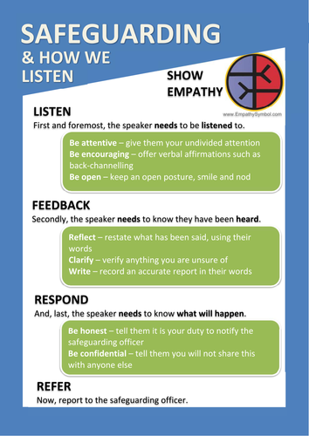
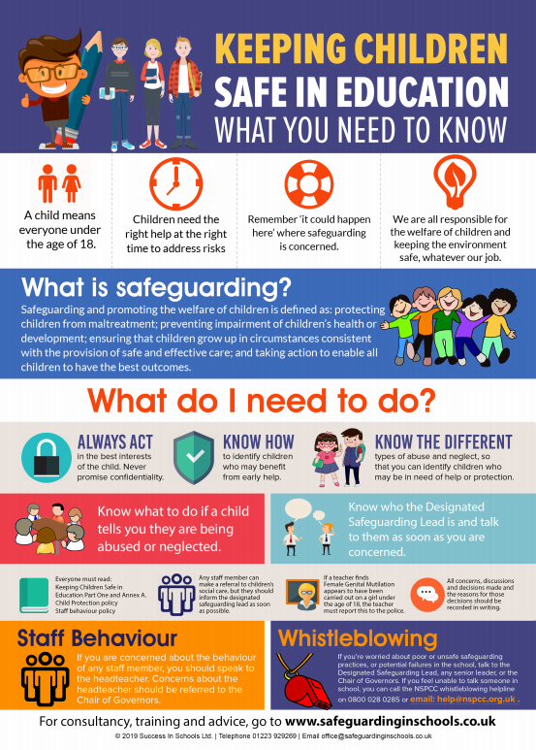
Pickup Dance has a child protection policy to ensure the highest standard of care and tuition for its students. In writing the policy we used STOPCHECK an NSCPP guide as well as GOV.co.uk and the procedures we follow are laid down within these guidelines.

